**Oasis Centre invites community to celebrate National Aboriginal Day**

Jane Boehr  
Nipawin Journal  
Friday, June 12, 2015 9:49:32 MDT AM   
<http://www.nipawinjournal.com/2015/06/12/oasis-centre-invites-community-to-celebrate-national-aboriginal-day>

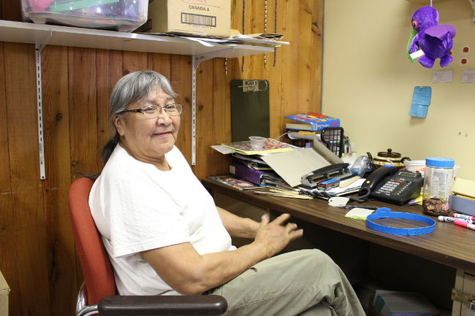

Harriet Burns and members at the Oasis Centre are planning for National Aboriginal Day

Harriet Burns works at the Oasis Centre. She says they are in the midst of planning a full schedule of events for National Aboriginal Day. She is excited to be planning for this event and says it's important to be able to share her culture with others.

"We will start at about 10 o'clock in the morning and we're going to do a teepee raising. [There will be] all kinds of fun activities, cooking bannock over a fire, there will be a fish pond. It's not traditional to have a fish pond but in a way I guess".

Burns has worked to share her culture for several years now and recalls a time when she taught Cree and did a special learning unit for a class at the old Junior High School in Nipawin. She says she's proud of her heritage and being able to teach others is what it's all about.

"It's to help children learn more about their heritage. They will be making headdresses, we were going to do animal calling... and we're going to try to do a sharing circle. And we will do something for the men to come and share something".

Burns says there will be several dozen volunteers planning to come from all over the area.

"Some resource people from Red Earth, Shoal Lake, and they will talk about Red Earth History. They'll have a table [set up]. I will talk about the life on the trap line and my dad who went through two world wars".

Every year National Aboriginal week kicks off with events across the country which lead up the National Aboriginal Day on June 21.

"We'll be posting up a schedule. There's usually a good turn out and lots of kids. We do our Cree too. We [will] talk Cree for the people that understand or if they are willing to learn".

Burns says all are invited to participate in the events, and are welcome to learn Cree from the Oasis Centre. She says everyone is invited to learn some other trades.

"Of course that's what it's all about. I have some non-native girls in my beading class. I'm proud of my heritage. I respect the people that want to learn about our culture. I enjoy it".

The Oasis Centre will be posting an official schedule of events later this week. For more information on National Aboriginal Day go to nipawinoasis.com.